KARNATAK LAW SOCIETY’S

GOGTE INSTITUTE OF TECHNOLOGY

UDYAMBAG, BELAGAVI-590008

(An Autonomous Institution under Visvesvaraya Technological University, Belagavi)

**(APPROVED BY AICTE, NEW DELHI)**



*Course Activity Report*

*On*

***Bed Tracking System for Covid Patients***

*Submitted in the partial fulfillment for the academic requirement**of*

***4th Semester B.E.***

***In***

***Computer Science Engineering***

***Submitted by***

**NAME USN**

Aaditya Chougala 2GI19CS007

Deepak Kumble2GI19CS038

Irfan Kamate2GI19CS052

Kartik Nanneboina 2GI19CS055

**GUIDE**

**Mr. Parimal Tergundi**

**2020 – 2021**

**Title:** Bed Tracking System for Covid Patients

**Team Members Details:**

|  |  |  |
| --- | --- | --- |
| **S. No.** | **USN** | **Student Name** |
| 1 | 2GI19CS007 | Aaditya Chougala |
| 2 | 2GI19CS038 | Deepak Kumble |
| 3 | 2GI19CS052 | Irfan Kamate |
| 4 | 2GI19CS055 | Kartik Nanneboina |

**Marks allocation:**

|  |  |  |  |  |  |  |
| --- | --- | --- | --- | --- | --- | --- |
|  | Batch No. : 1 | | | | | |
| 1. | Project Title:  ***Bed Tracking System for Covid Patients*** | Marks Range | USN | | | |
| 2GI19CS007 | 2GI19CS038 | 2GI19CS052 | 2GI19CS055 |
| 2. | Problem statement (PO2) | 0-1 |  |  |  |  |
| 3. | Need Analysis, Variables involved (PO1,PO2) | 0-2 |  |  |  |  |
| 4. | Alternate solutions to solve the problem(PO3) | 0-3 |  |  |  |  |
| 5. | Comparison between the solutions and reason for selecting the final solution(PO1,PO3,PO4) | 0-4 |  |  |  |  |
| 6. | Working model of the final solution (PO3,PO12) | 0-5 |  |  |  |  |
| 7. | Report and Oral presentation skill (PO9,PO10) | 0-5 |  |  |  |  |
|  | Total | 20 |  |  |  |  |

**Signature of Staff**

***PROBLEM STATEMENT:***

We have come up with an idea of creating a software which allows needy to :

1- Check a list of hospitals with various kinds of beds available.

2- Check the availability of oxygen in hospitals.

3- The software contains details of a list of all hospitals across the state.

4- Any needy patient or one who is suffering can easily track down a hospital with the necessary requirement on a single tap.

***Advantages:***

1- The software will be user friendly having friendly interfaces thereby needing no information/training of his you use the system/software.

2- Any patient can get immediate details of the hospital.

3- Since a software helps the patients for getting information about various needs, the user doesn't need to step out of the door to check the same, thereby decreasing the possibilities of either getting infected or infecting others.

4- Realtime database keeps track of the beds being occupied and vacant almost immediately after the patient is admitted/discharged thereby giving a real time information.

5- The software is divided into 3 parts.

1. One is handled by the main admin(government body) to handle details of total beds allocated to a particular hospital, oxygen allotment etc.
2. The admin of hospital to manage the real-time data.
3. The user who uses the software.

***Why do we need a software for this purpose?***

1- The present situation has a created great chaos not only among people but also between hospitals and governments.

2- This has led to unorganized situations where we, people, don't have a platform for getting help with any information.

3- In such situations, a virtual(software) mean(if available) makes (atleast) somethings organized and a good awareness can be spread.

4- This in turn reduces the chaos around us.

5- More points already discussed in Advantages section.

***OUTPUTS:***

Home page:

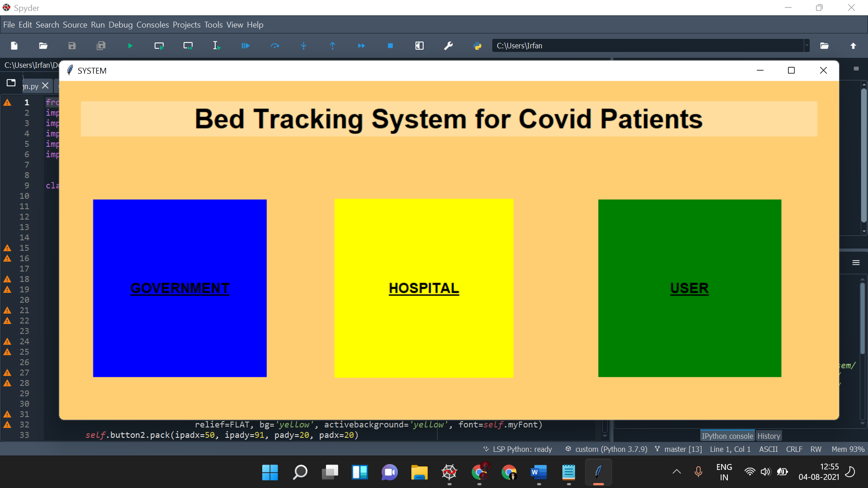

GOVERNMENT page:

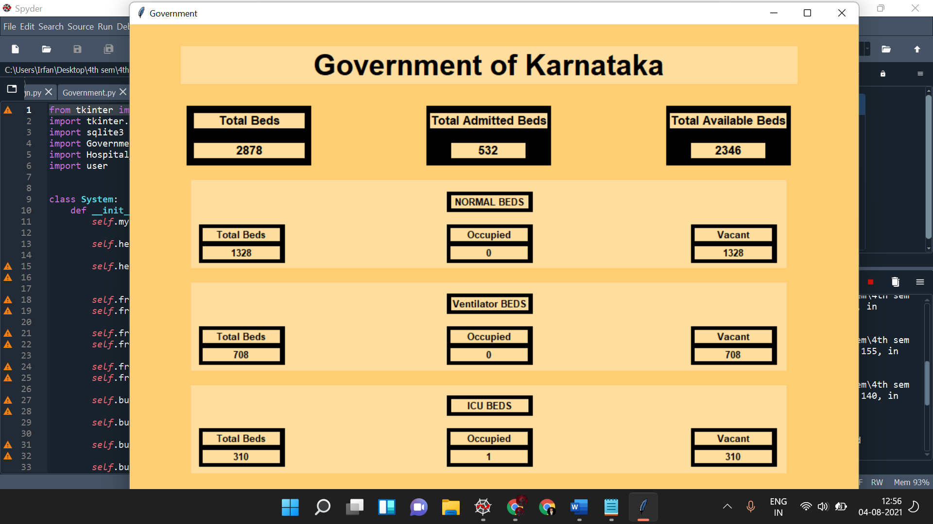

USER page:

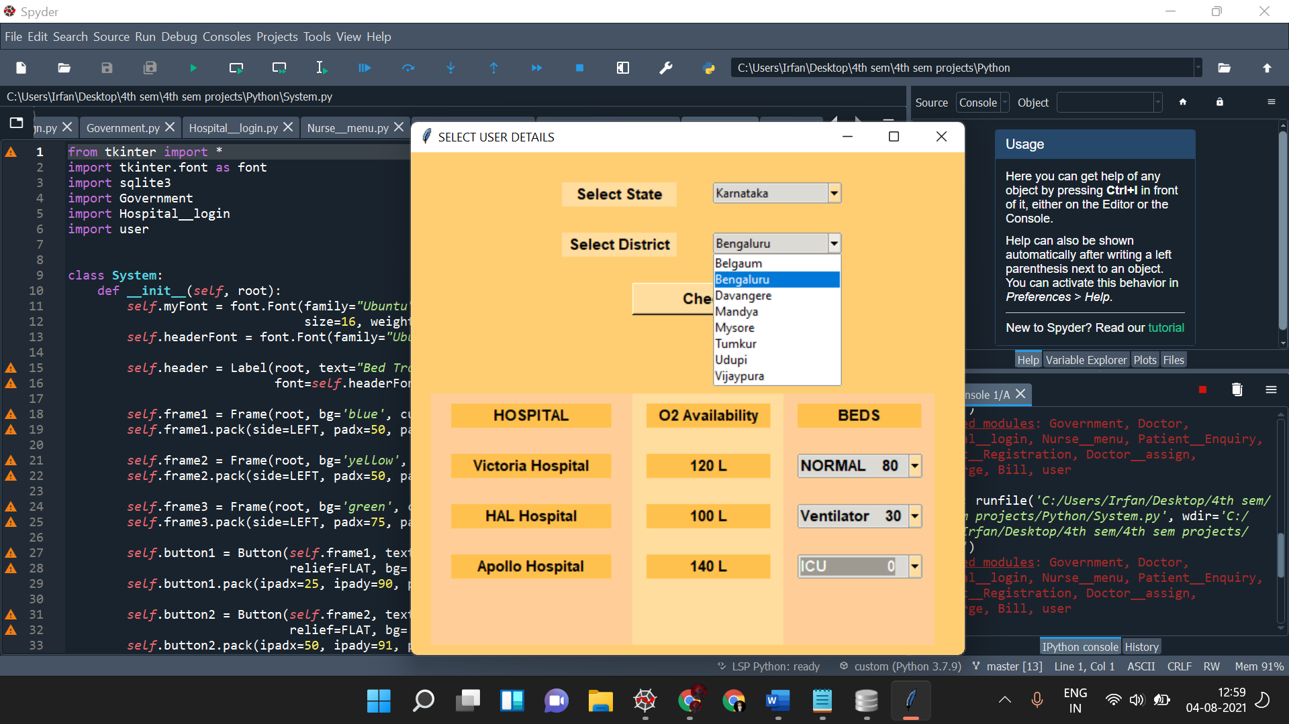

HOSPITAL LOGIN:

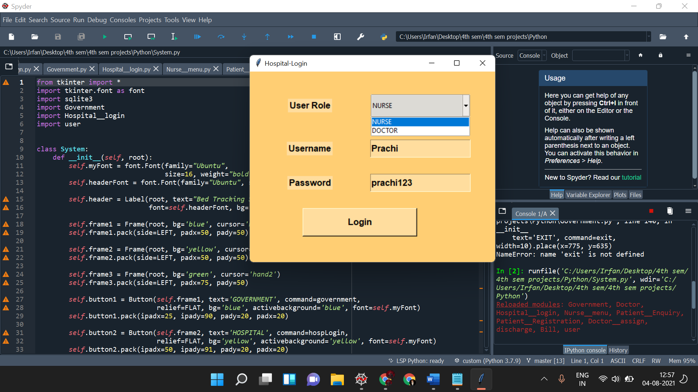

NURSE MENU:

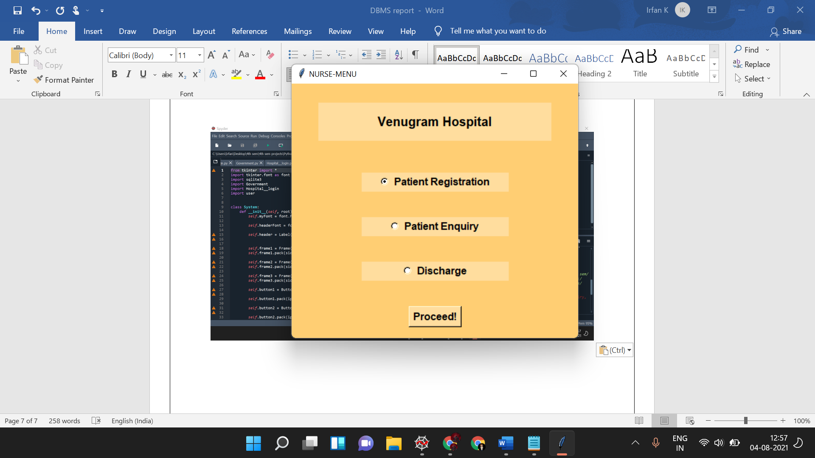

PATIENT REGISTRATION:

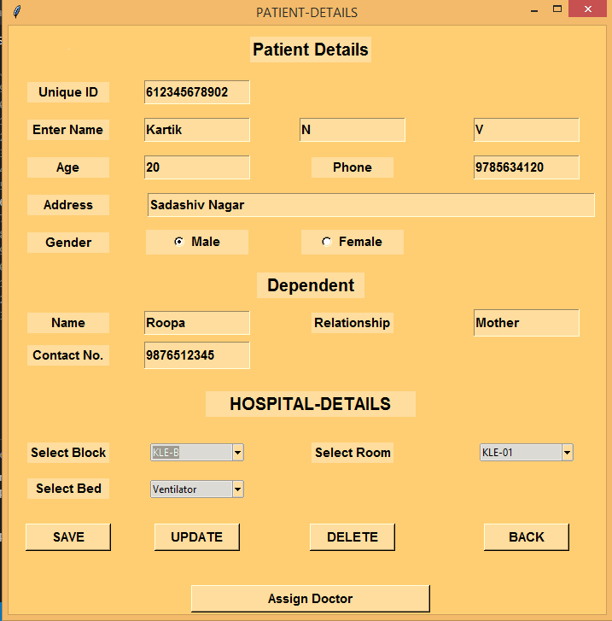

ASSIGNING DOCTOR:

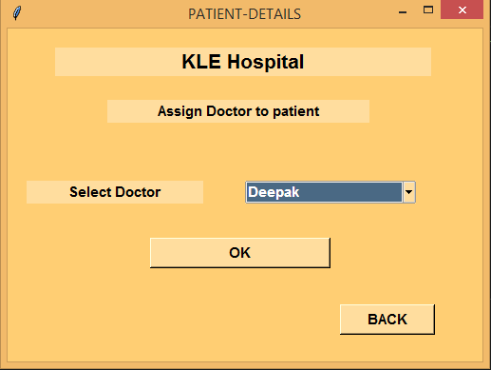

PRESCRIBING MEDICINES(DOCTOR):

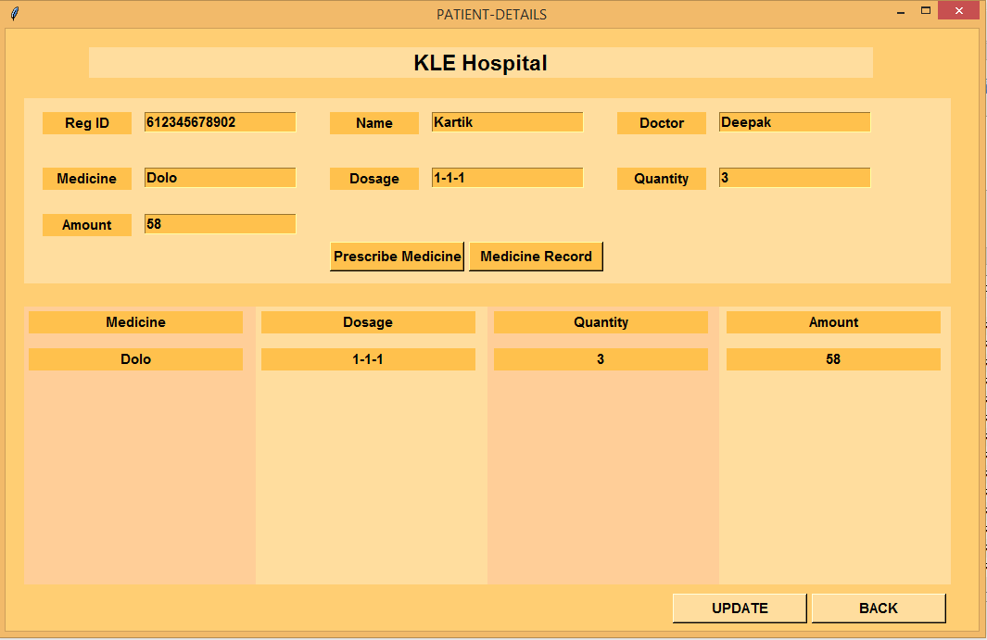

PATIENT ENQUIRY:

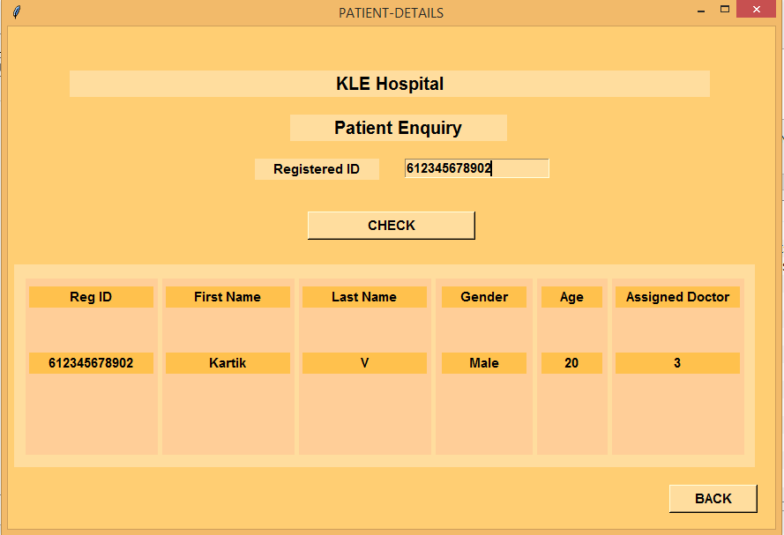

DISCHARGE:

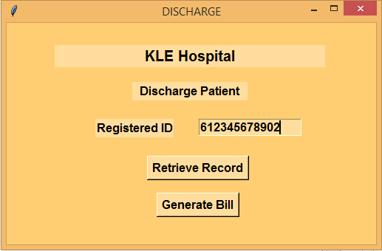

BILL:

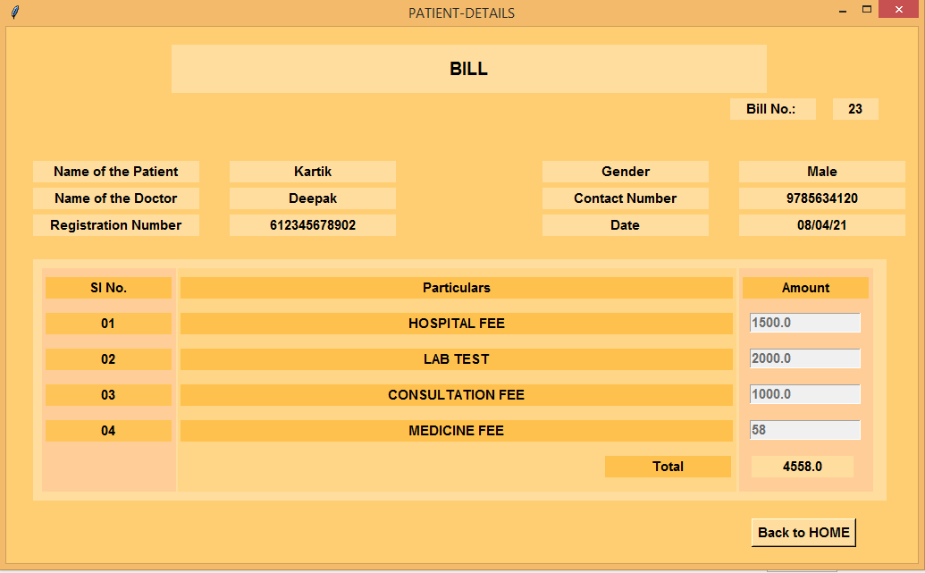

***Conclusion:***

We have built a complete BED TRACKING SYSTEM from front-end to back-end and successfully connected it to data-base. Also, all the queries written help data to be retrieved, updated and inserted. The system also has proper authentication served up so as to minimize logical and database transactional errors.